Group Project Data Description

The data of our group project: The housing price data in Beijing from 2011 to 2017.
Features include:
- url: the url of the housing on Lianjia platform
- id: id of the housing
- Lng: longitude of the housing location
- Lat: lattitude of the housing location
- Cid: community id
- tradeTime: time of the trade
- DOM: active days on market
- followers: the number of people follow the transaction.
- totalPrice: the total price
- price: the average price by square
- square: the square of the house
- livingRoom: number of living rooms
- drawingRoom: number of drawing rooms
- kitchen: number of kitchen
- bathroom: number of bathroom
- floor: height of the house
- buildingType: 1 for tower, 2 for bungalow, 3 for combination of plate and tower, 4 for plate
- constructionTime: time of construction
- renovationCondition: 1 for other, 2 for rough, 3 for simplicity, 4 for hardcover
- buildingStructure: 1 for unknow, 2 for mixed, 3 for brick and wood, 4 for brick and concrete, 5 for steel, 6 for steel-concrete composite
- ladderRatio: the proportion between number of residents on the same floor and number of elevator of ladder, describes how many ladders a resident have on average
- elevator: 1 for have and 0 for no
- fiveYearsProperty: if the owner have the property for less than 5 years

We plan to apply machine learning methodologies on the dataset to try some topics such as predictive analysis, anomaly detection, time series analysis, clustering, etc.

The distribution chart image of some features are shown below.
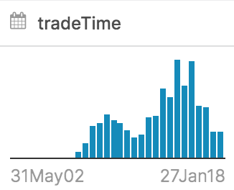 | 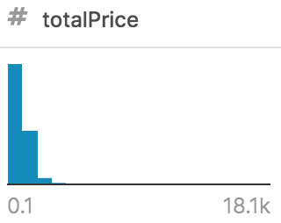 | 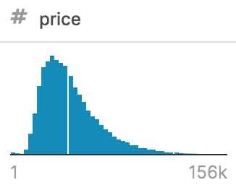 | 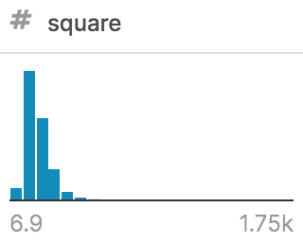
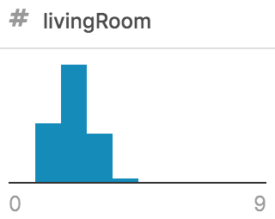 | 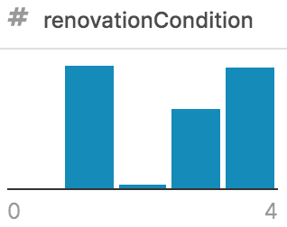 | 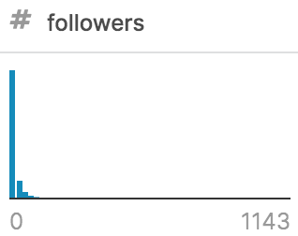 | 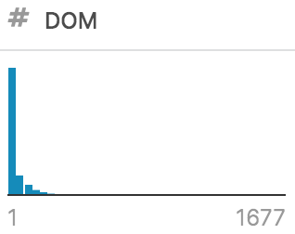
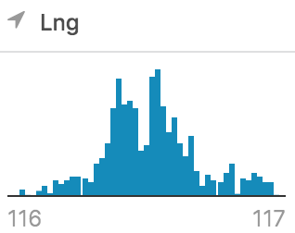 | 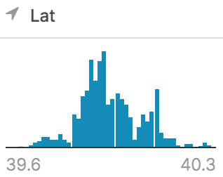 | 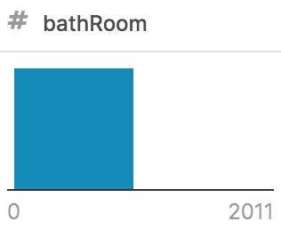 | 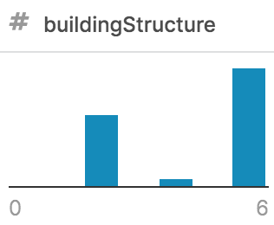

Group Members: Xiaohan Zhang, Chiehen Hung, Hankun Li

